Recursion is a technique in which a function repeatedly calls itself till a certain breakpoint condition is reached. It simplifies some problems, by breaking the actual problem into sub-problems and solving them.

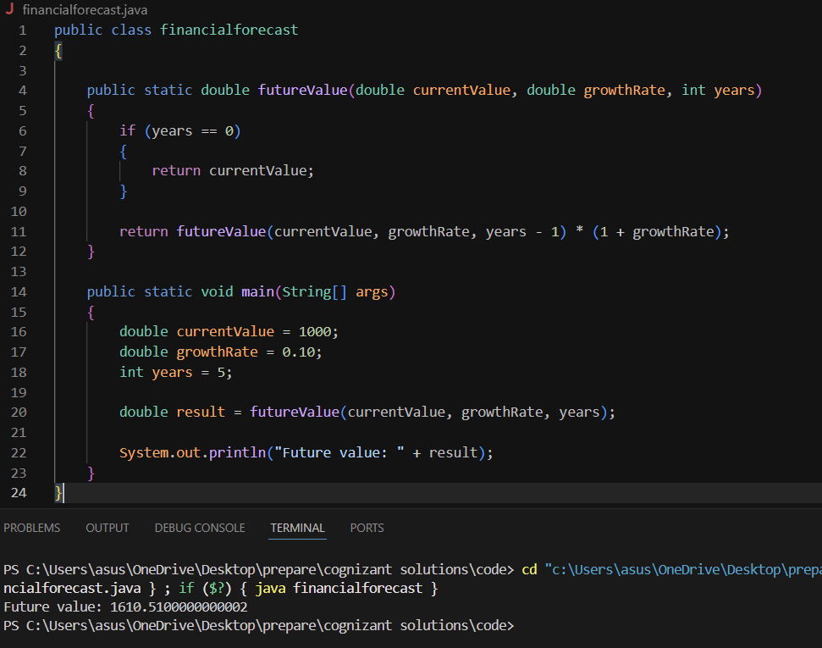

Time Complexity: O(n)
Because, one recursive call for each year.

For this problem we can use an iterative approach i.e. using a loop instead of using recursion, for optimization and avoiding excessive computation.

